Practical 9

SQL queries to implements various string manipulation functions on different data set and table data.

**Query1. Write a SQL query to perform String manipulation function UCASE () to change author name in uppercase.**

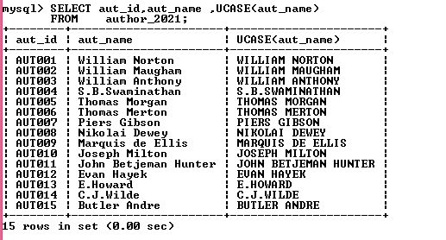

**Query2. Write a SQL query to perform String manipulation function LCASE () to change author name in Lowercase.**

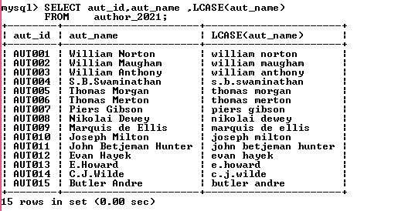

**Query3. Write a SQL query to show the ASCII value of the String .**

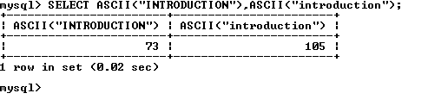

**Query4. Write a SQL query to perform BIT_LENGTH () to show the length of the book name’ Introduction to Electrodynamics’ for table book_mast_2120.**

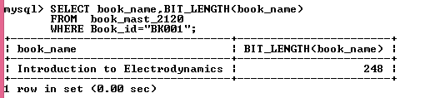4

**Query5. Write a SQL query to perform CONCAT () to connect the EMP_FNAME, EMP_LNAME as EMP_NAME without space in fname and lname.**

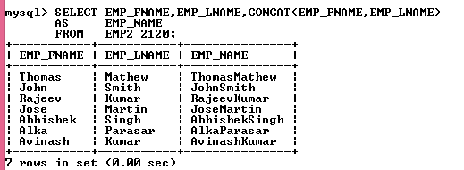

**Query6. Write a SQL query to list out the substring from a string using SUBSTRING () in customer table**

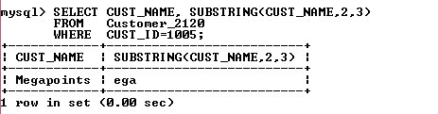

**Query7. Write a SQL query to perform CONCAT () to connect the EMP_FNAME, EMP_LNAME as EMP_NAME without space in fname and lname.**

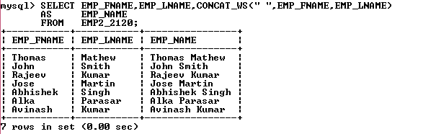

**Query8. Write a SQL query to perform the REVERSE String () to reverse the book name ‘Understanding of Steel Construction ‘.**

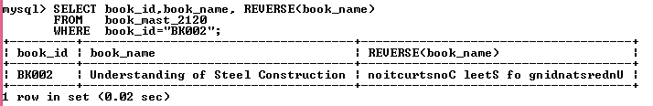

**Query9. Write a SQL query to perform the REPLACE () to replace the publication language English to Hindi in Book_mast_table_2120.**

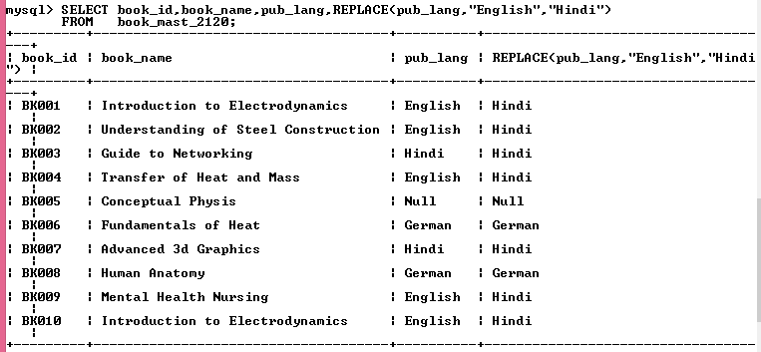

**Query10. Write a SQL query to perform a FIND_IN_SET string query in author_2120 table**.

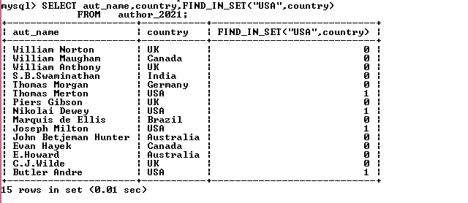

**Query11. Write a SQL query to perform REPEAT () in author _table the country name where author id “AUT001”, “AUT009”.**

**.**

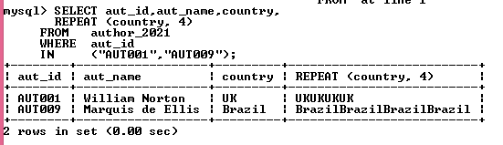

**Query12. Write a SQL query to perform a REVERSE () the country name where author id “AUT001”,”AUT009”.**

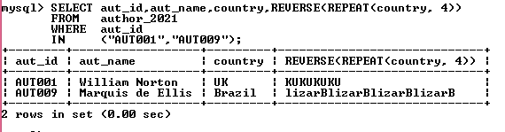

**Query13. Write a SQL query to perform RTRIM () in book mast table.**

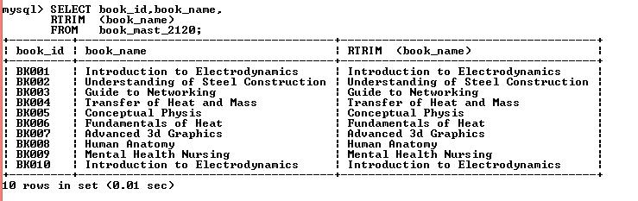

**Query14. Write a SQL query to perform LTRIM () in book mast table.**

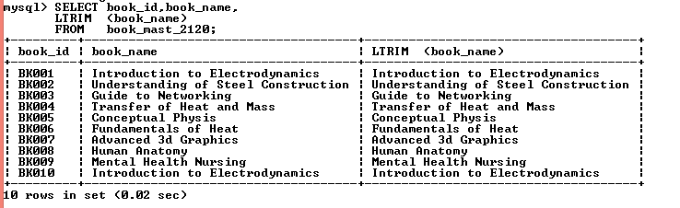

**Query15. Write a SQL query to perform LPAD() string function in book mast table where book_mast table.**

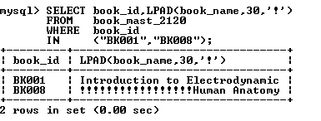

**Query16. Write a SQL query to perform RPAD () string function in book mast table where book_mast table**

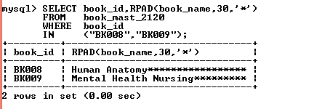

**Query17. Write a SQL query to perform LEFT string function in product_2120 table.**

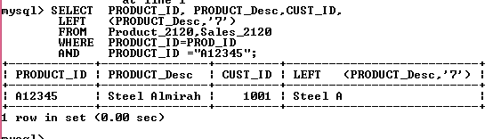

**Query18. Write a SQL query to perform RIGHT string function in the Product-2120 table.**

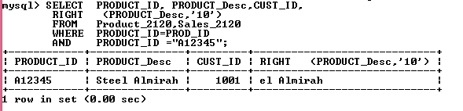

**Query19. Write a SQL query to perform STRCMP () in the book_mast, publisher table.**

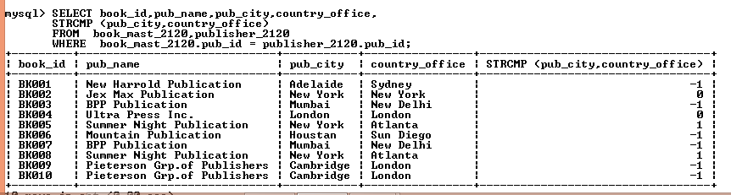

**Query20. Write a SQL query to perform QUOTE string ().**

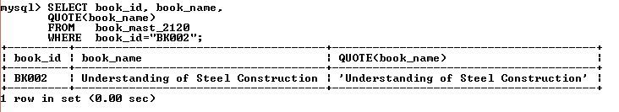**Query21. Write a SQL query to perform a ORD sting function where book id is ‘BK002.’**

